**HIVE ASSIGNMENT-1**

**Question Statement:**

1. Download vehicle sales data -> https://github.com/shashank-mishra219/Hive-Class/blob/main/sales_order_data.csv

2. Store raw data into hdfs location

3. Create a internal hive table "sales_order_csv" which will store csv data sales_order_csv .. make sure to skip header row while creating table

4. Load data from hdfs path into "sales_order_csv"

5. Create an internal hive table which will store data in ORC format "sales_order_orc"

6. Load data from "sales_order_csv" into "sales_order_orc"

Perform below menioned queries on "sales_order_orc" table :

a. Calculatye total sales per year

b. Find a product for which maximum orders were placed

c. Calculate the total sales for each quarter

d. In which quarter sales was minimum

e. In which country sales was maximum and in which country sales was minimum

f. Calculate quartelry sales for each city

h. Find a month for each year in which maximum number of quantities were sold

Data Preparation:

Copied the file to HDFS location:

**hdfs dfs -put 'file:///home/cloudera/data/sales_order_data.csv' /tmp/hive_data/**

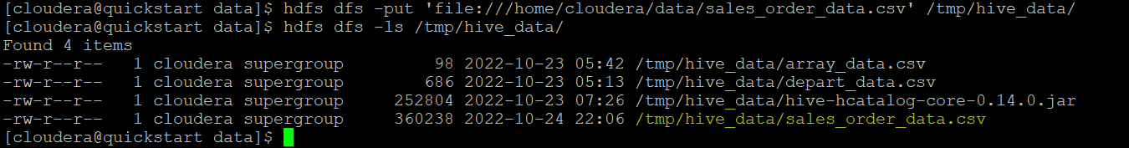

Create separate database for assignments.

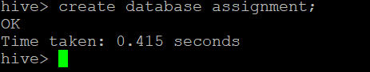

Create table sales_data;

DDL :

create table sales_order_data(

ORDERNUMBER int,

QUANTITYORDERED int,

PRICEEACH float,

ORDERLINENUMBER int,

SALES float,

STATUS string,

QTR_ID int,

MONTH_ID int,

YEAR_ID int,

PRODUCTLINE string,

MSRP int,

PRODUCTCODE string,

PHONE string,

CITY string,

STATE string,

POSTALCODE string,

COUNTRY string,

TERRITORY string,

CONTACTLASTNAME string,

CONTACTFIRSTNAME string,

DEALSIZE string

)

row format delimited

fields terminated by ','

tblproperties("skip.header.line.count"="1");

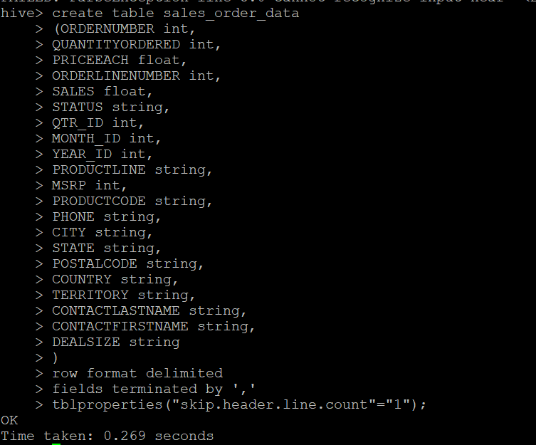

Load data from HDFS location into table sales_order_data.

**load data inpath '/tmp/hive_data/sales_order_data.csv' into table sales_order_data;**

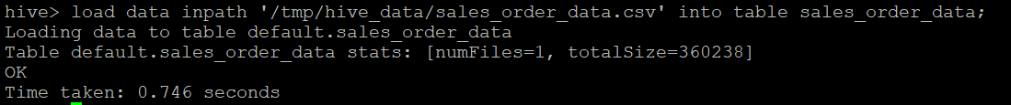

set hive.cli.print.header=true;

select * from sales_order_data limit 5;

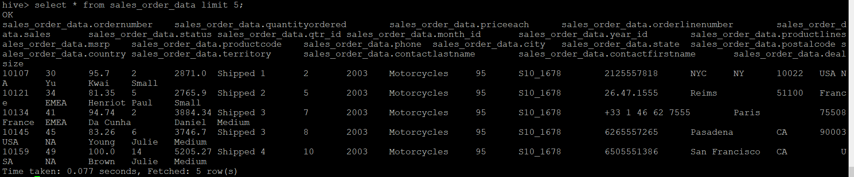

Create a ORC Table:

create table sales_order_data_orc (

ORDERNUMBER int,

QUANTITYORDERED int,

PRICEEACH float,

ORDERLINENUMBER int,

SALES float,

STATUS string,

QTR_ID int,

MONTH_ID int,

YEAR_ID int,

PRODUCTLINE string,

MSRP int,

PRODUCTCODE string,

PHONE string,

CITY string,

STATE string,

POSTALCODE string,

COUNTRY string,

TERRITORY string,

CONTACTLASTNAME string,

CONTACTFIRSTNAME string,

DEALSIZE string

)

Stored as orc;

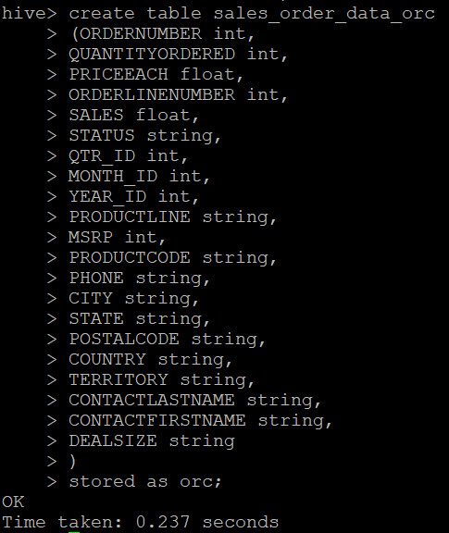

Load data from **sales_order_data** into **sales_order_data_orc**

**insert overwrite table sales_order_data_orc select * from sales_order_data;**

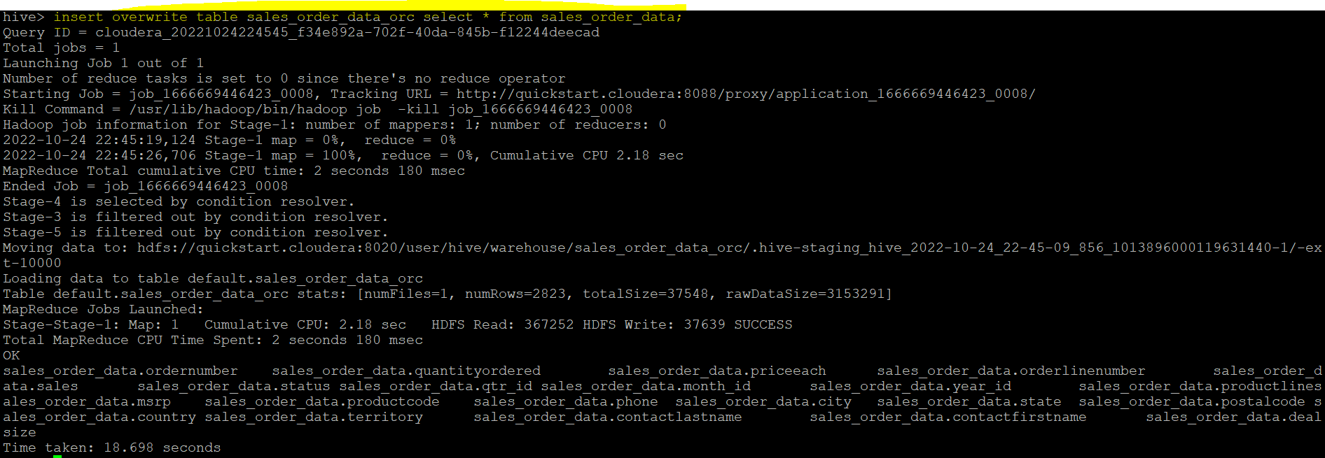

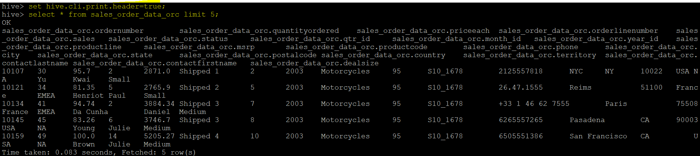

Perform below mentioned queries on "sales_order_data_orc" table

1. **Calculate total sales per year**

**select round(sum(sales),2) as total_sales_per_year,year_id from sales_order_data_orc group by year_id;**

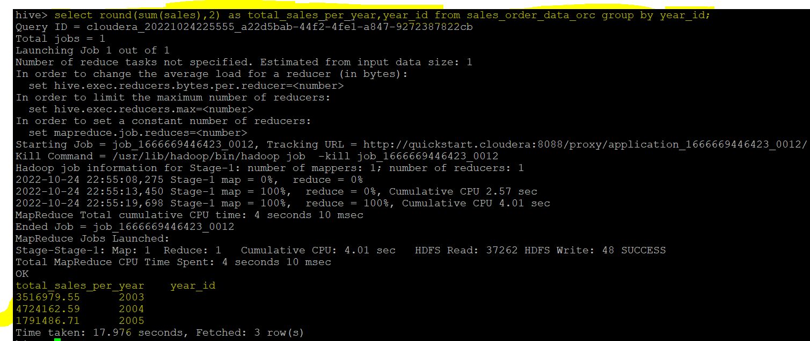

1. **Find a product for which maximum orders were placed**

**select count(ordernumber) as cnt,productline from sales_order_data_orc group by productline order by cnt desc limit 1 ;**

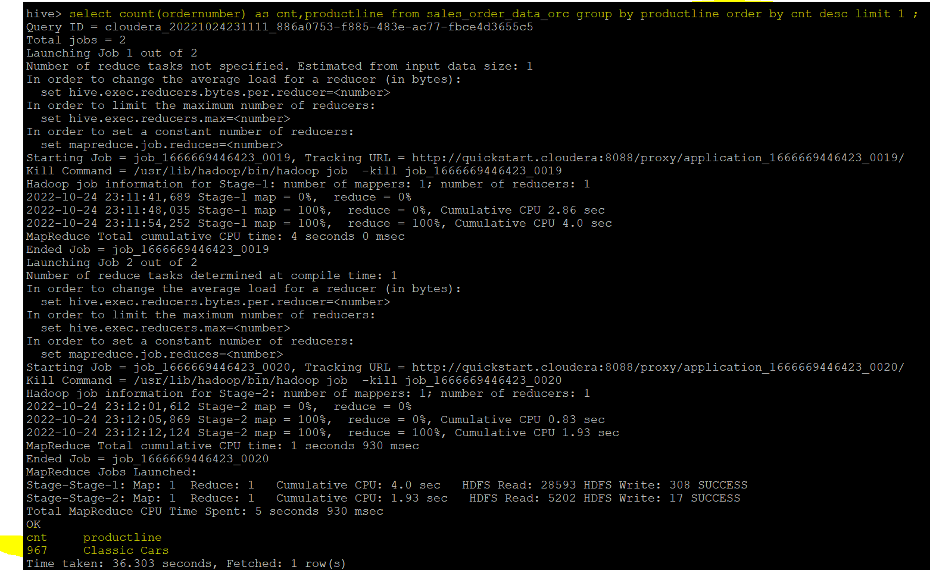

1. **Calculate the total sales for each quarter**

**select round(sum(sales),2) as total_sales_per_quarter,qtr_id from sales_order_data_orc group by qtr_id;**

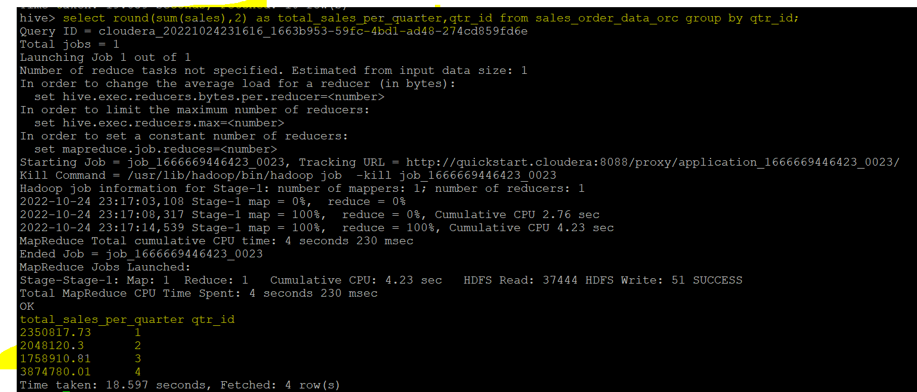

1. **In which quarter sales was minimum**

**select round(sum(sales),2) as total_sales_per_quarter,qtr_id from sales_order_data_orc group by qtr_id order by total_sales_per_quarter limit 1;**

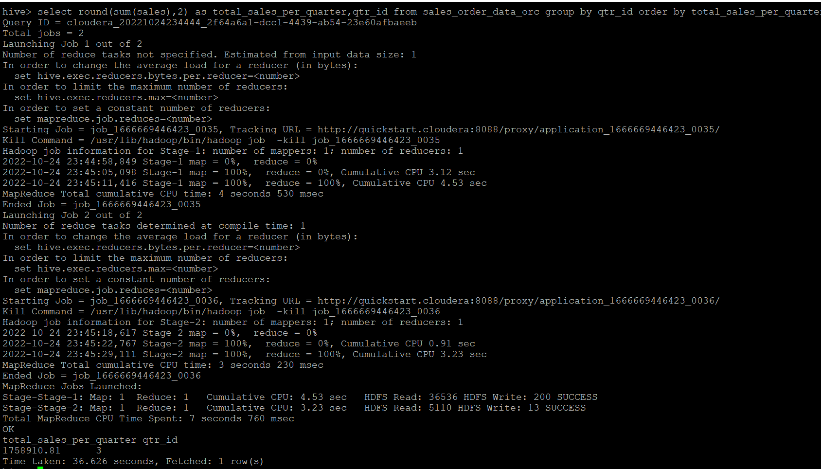

1. **In which country sales was maximum and in which country sales was minimum**

**Maximum:**

**select round(sum(sales),2) as max_sales_country,country from sales_order_data_orc group by country order by max_sales_country desc limit 1;**

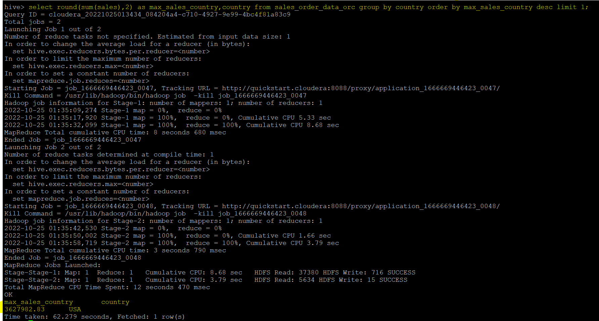

**Minimum:**

**select round(sum(sales),2) as min_sales_country,country from sales_order_data_orc group by country order by min_sales_country asc limit 1;**

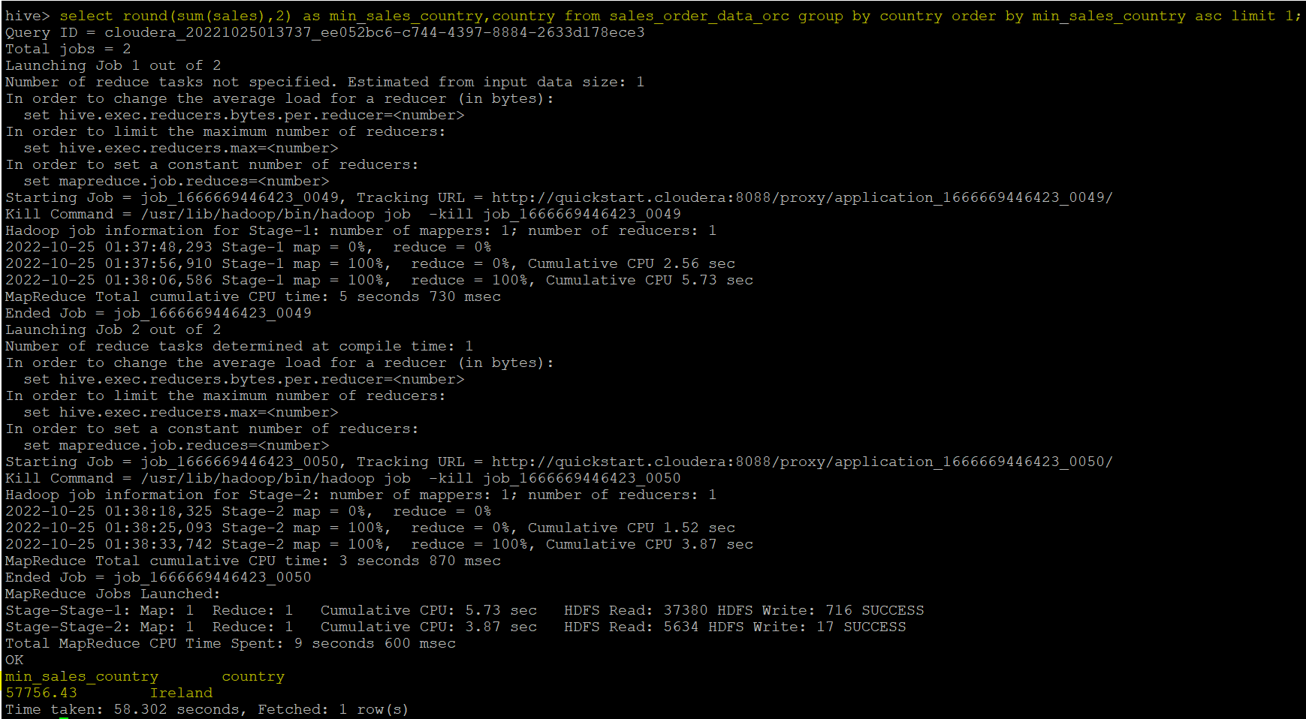

1. **Calculate quarterly sales for each city**

**select round(sum(sales),2) as qtr_sales_per_city,qtr_id,city from sales_order_data_orc group by qtr_id,city;**

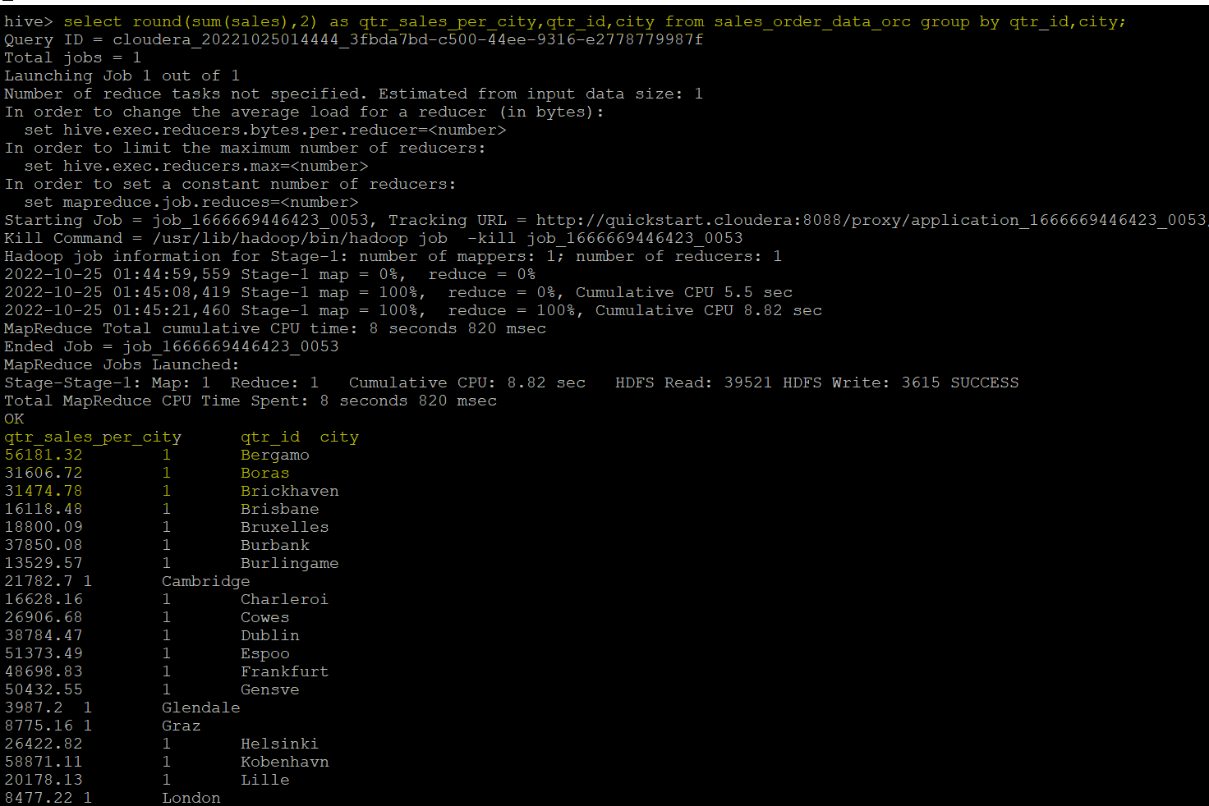

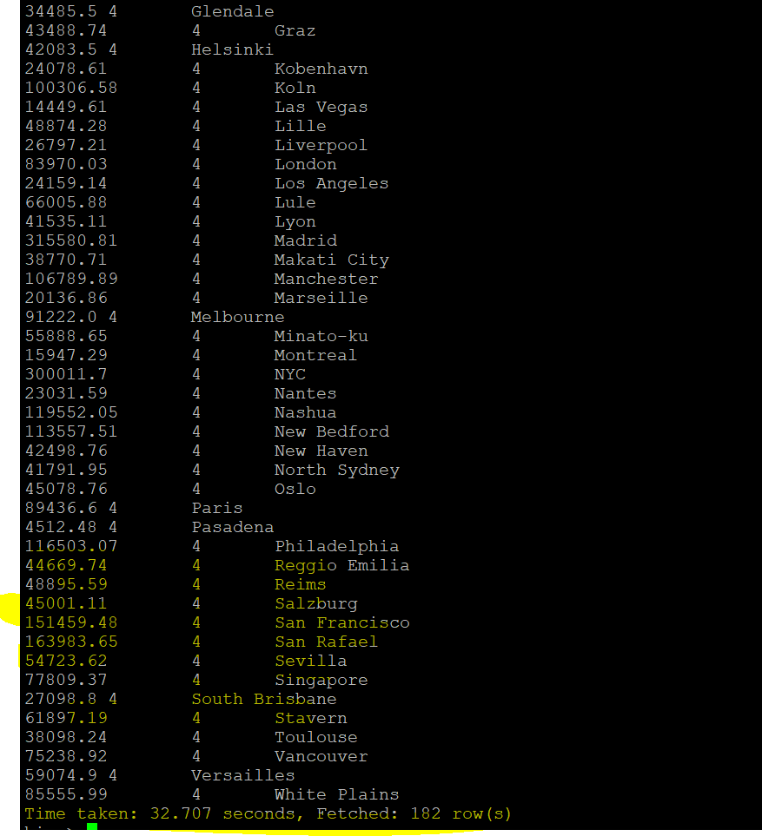

1. **Find a month for each year in which maximum number of quantities were sold**

**select b.max_qty_per_month_year as max_qty_per_month_year,b.month_id,b.year_id from**

**(select a.*, rank () over (partition by a.year_id order by a.max_qty_per_month_year desc) as rnk from**

**(select sum(quantityordered) as max_qty_per_month_year,month_id,year_id from sales_order_data_orc group by month_id,year_id order by max_qty_per_month_year desc) a)b**

**where b.rnk=1**

